Final Project:
  - Friendly Skies, inc.
  - Angelina DeMarinis



Table of Contents
Network Diagram 1
ADDS Diagram 2
Server #1 screenshot 3
Server #2 screenshots 4
Server #3 Screenshots 5
OU Screenshots 6
Shared Folder Screenshots………………………………………………………….…………………………………………………….7

Planning document:
Name: Friendly Skies, Inc.
Servers: American, United, Jetblue
- Server 1: American
  - Roles: ADDS, DNS
  - IP: 192.168.254.1
  - DNS: 192.168.254.1
- Server 2: United
  - Roles: ADDS, DNS
  - IP:192.168.254.2
  - DNS:192.168.254.1
- Server 3: Jetblue
  - Roles: ADDS, DNS
  - IP: 192.168.254.3
  - DNS: 192.168.254.1
OU’s
Groups: Flight Attendants, Pilots, and Gate Agents
G_Flightattandent
- Name: Angelina
- User: Ang
- Name: Isabella
- User: Bella
- Name: Semma
- User: Semma
G_Pilot
- Name: Philippe
- User: Phil
- Name: Theodore
- User: Teddy
- Name Jad
- User: Jad
G_Gateagent
- Name: Brandy
- User: Brandy
- Name: Daphnee
- User: Daph
- Name: Melanie
- User: Mel

Network Diagram:

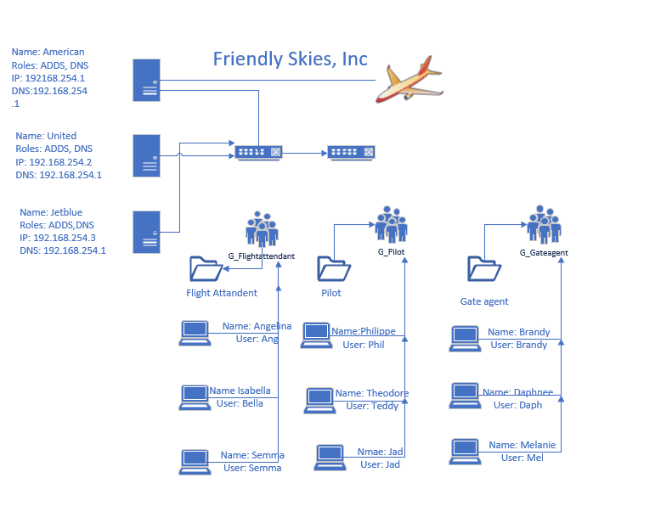

ADDS Diagram:



Server #1 Screenshots:

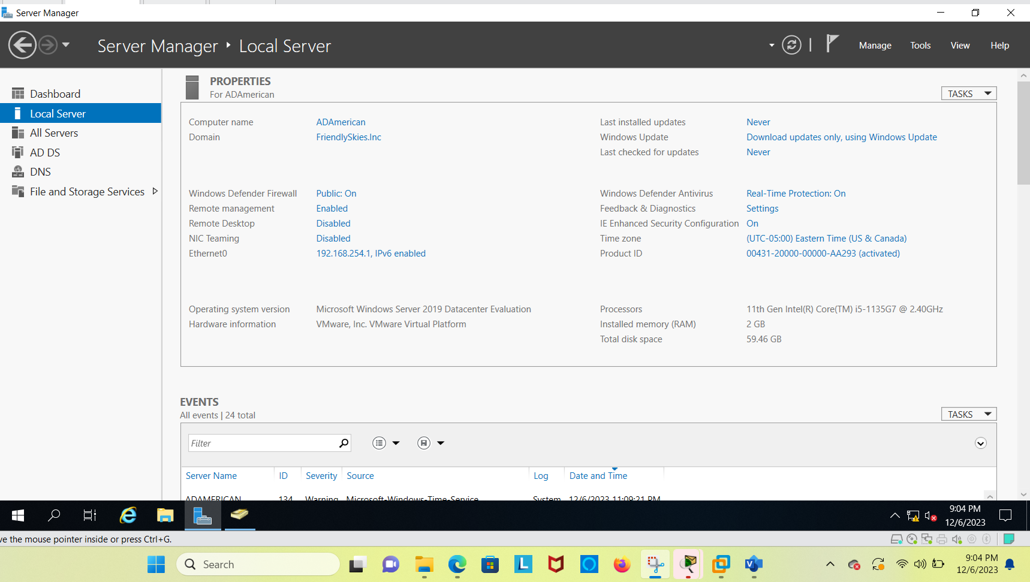
IP Address entered, Domain created, Computer name changed, Time Zone changed, and Roled added

Server # 2 Screenshots:

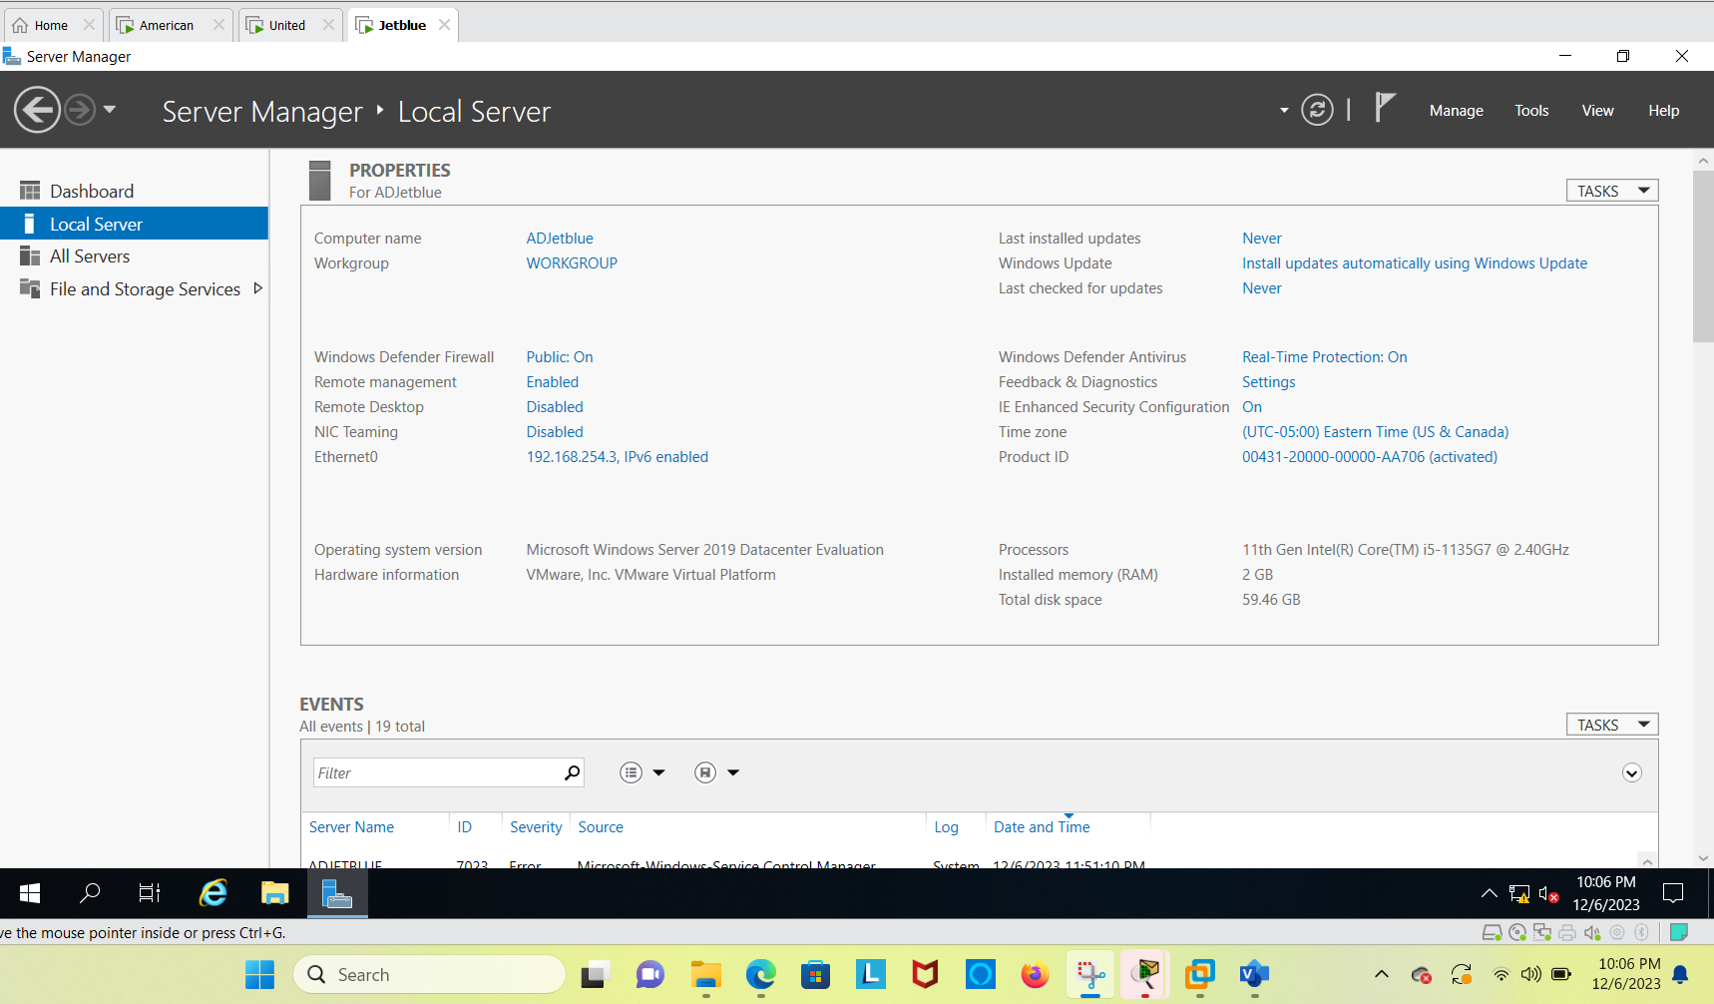
IP Address entered, Domain created, Computer name changed, Time Zone changed, and Roled added

Server #3 Screenshots:

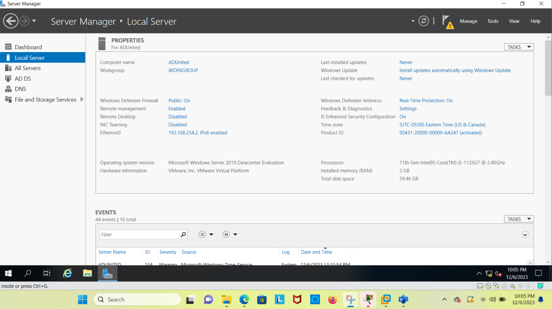
IP Address entered, Domain created, Computer name changed, Time Zone changed, and Roled added

OU Screenshots:

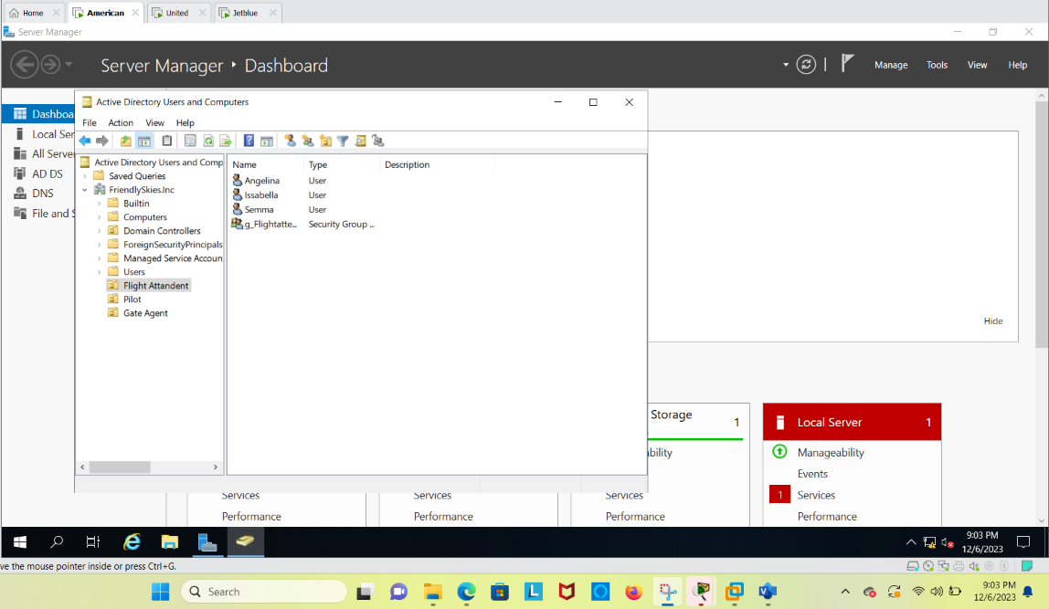
Flight Attendant groups and names created

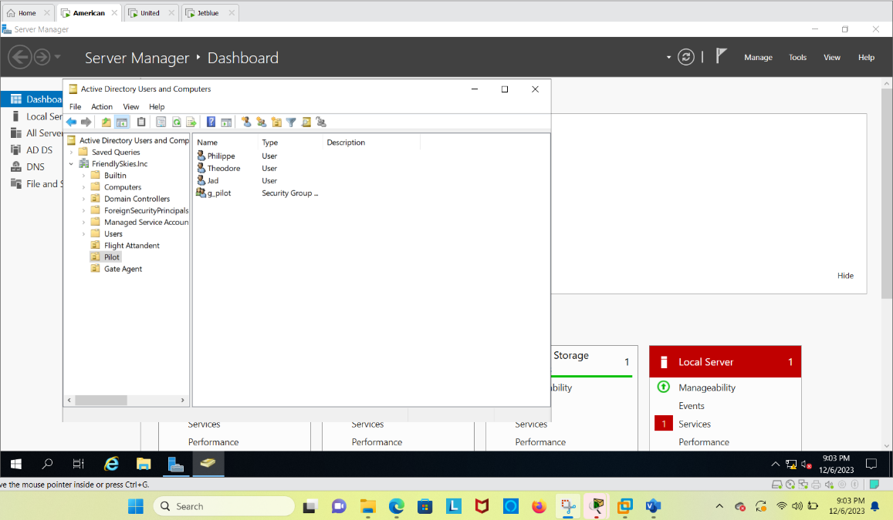
Pilot groups and names created

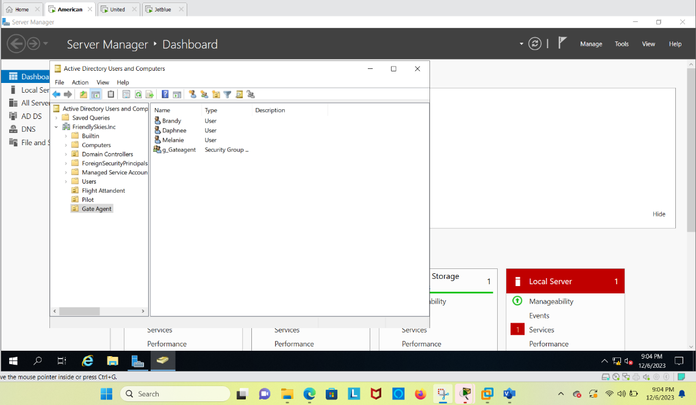
Gate Agent group and names created

Shared Folder Screenshots:
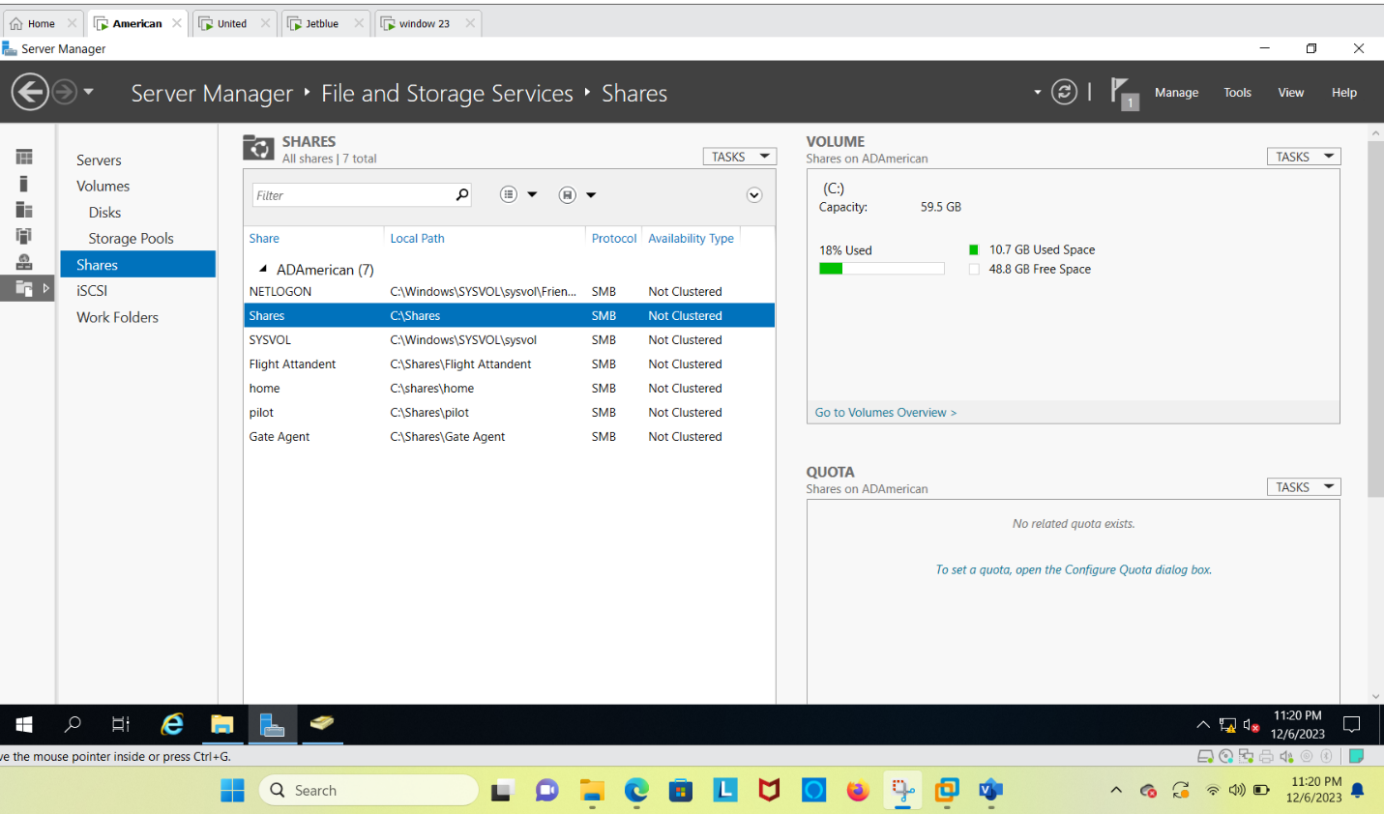
Shared folders for each OU
